💳 Payment Processor Service

📌 Overview
The Payment Processor is a high-throughput, event-driven microservice designed to process payments asynchronously using Apache Kafka.

Responsibilities
- Consume payment events from Kafka
- Apply business rules
- Ensure idempotent processing
- Persist results in database
- Publish processed outcomes

🧱 Architecture

🔷 High-Level Architecture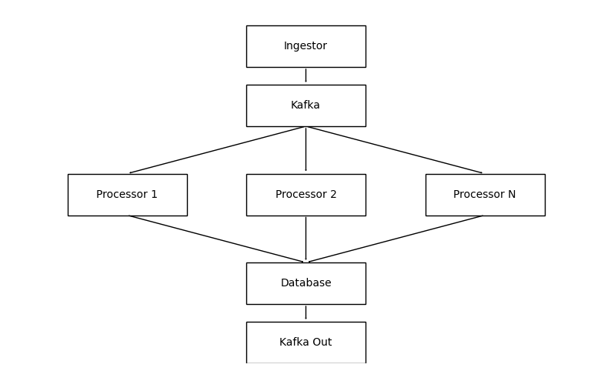

🔄 Processing Flow
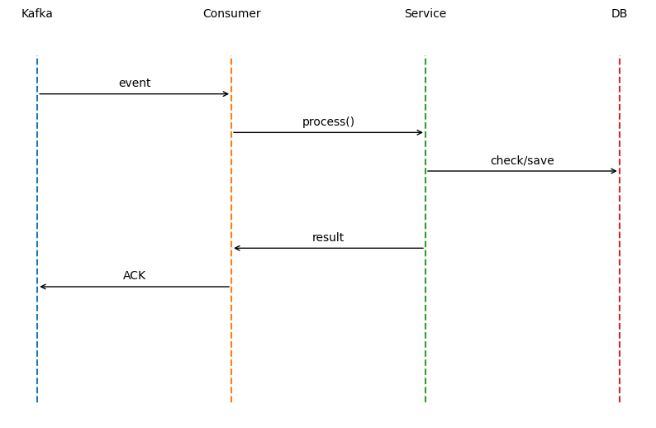

🧠 Core Design Principles
- ✅ At-least-once delivery
- ✅ Strong consistency
- ✅ Idempotent processing
- ✅ Manual acknowledgment
- ✅ Horizontal scalability
- ✅ DLQ

🏗️ Project Structure
com.payment.processor
│
├── consumer # Kafka listeners
├── producer # Kafka publishers
├── service # Business logic
├── repository # JPA layer
├── entity # DB entities
├── dto # Kafka payloads
├── config # Kafka & Retry config
├── exception # Error handling
└── util # Utilities

📥 Kafka Consumer
@KafkaListener(
topics = "payments.submitted",
groupId = "payment-processor-group",
concurrency = "12"
)
public void consume(PaymentEvent event, Acknowledgment ack) {
try {
processorService.process(event);
ack.acknowledge();
} catch (Exception ex) {
// no ACK → Kafka retry
}
}

🧠 Processing Logic
@Transactional
public void process(PaymentEvent event) {

if (repository.existsByPaymentId(event.getPaymentId())) {
return;
}

PaymentOutcome outcome = applyRules(event);

saveWithRetry(outcome);

kafkaProducer.send(outcome);
}

⚖️ Business Rules
Condition | Status
Same account | REJECTED
Amount > 250,000 | HELD
Otherwise | PROCESSED

🛡️ Idempotency Strategy
- DB check: existsByPaymentId
- DB constraint: UNIQUE(payment_id)

Why both?
- Fast detection + final protection

💾 Database Schema
CREATE TABLE payment_outcomes (
id BIGINT AUTO_INCREMENT PRIMARY KEY,
payment_id UUID UNIQUE,
debit_account_id VARCHAR,
credit_account_id VARCHAR,
amount DECIMAL,
currency VARCHAR,
status VARCHAR,
processed_at TIMESTAMP,
processing_time_ms BIGINT
);

🔁 Retry Strategy
@Retryable(
maxAttempts = 3,
backoff = @Backoff(delay = 100, multiplier = 2)
)
public void saveWithRetry(PaymentOutcome entity) {
repository.save(entity);
}

Behavior
- Retry transient DB failures
- If still fails → Kafka retries (no ACK)

⚙️ Kafka Configuration

Consumer
enable-auto-commit: false
ack-mode: MANUAL
max-poll-records: 500
auto-offset-reset: earliest

Producer
acks: all
enable-idempotence: true
compression-type: snappy
linger-ms: 5

⚠️ Failure Handling
Scenario | Behavior
DB failure | Retry → Kafka retry
Duplicate message | Skip
Crash after DB write | Safe (idempotent)
Business failure | Mark REJECTED

🚀 Scaling Strategy
- Increase Kafka partitions (24+ recommended)
- Scale consumers horizontally
- Concurrency = partitions

📊 Performance Optimizations
- Batch polling (max.poll.records)
- Compression (snappy)
- DB indexing on payment_id
- Connection pooling tuning

🔮 Future Enhancements
- Redis for idempotency caching
- Observability (Prometheus, Grafana)
- Circuit breaker (Resilience4j)
- Data archival strategy

✅ Summary
This system ensures:
- 🔒 Strong consistency
- ⚡ High throughput
- 🔁 Reliable retry mechanism
- 🛡️ Duplicate protection

👨‍💻 Author
Designed as part of a production-grade payment processing system using Kafka and Spring Boot.

